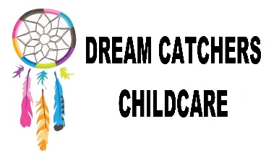

Behaviour Management Policy

Policy Written by – Mrs Leah Benford

Date written – 13.11.22

Reviewed - 13.11.23, 24.02.2024, 29.01.2025

Behaviour management policy

As a registered Play school, After School Club and holiday club, it is our duty to keep children safe from harm whilst in our care. It is important to set boundaries from the offset and for staff to act as a role model for the children. All children and their adults will be happily welcomed into our premises where they will be treated with care, respect, friendliness and courtesy.

We aim to provide an environment where everything is safe and fun, children will be taught from the offset to share, take turns and socialise appropriately with their peers. By doing so the children will flourish and develop their social skills that will help them throughout their lives.

For the older school aged children, there will be “Dream Catcher” rules to set the boundaries and to ensure smooth running of the sessions and the children will be encouraged to write and participate in writing of these rules. For the younger children, we will engage in stories and age appropriate discussions around rules and boundaries. This will get all the children to feel valued, equal and informed of the rules.

Under no circumstances will any member of the Dream Catcher team use any physical chastisement, or any other form of punishment that will cause the child any harm physically or emotionally.

Procedure

We will use positive strategies for handling any conflicts by helping children find solutions in ways that are appropriate for their age and stage of development- for example distraction, discussion, praising etc.

We will encourage appropriate behaviour by;

* Setting boundaries and group rules.
* Praising the children for good examples of behaviour
* Being consistent with techniques and explanations of why some behaviours are unacceptable.
* Recognising, praising and sharing positive behaviours to their parents/carers.
* Understanding the age appropriateness and expectations for their ages.

Unwanted behaviours will be dealt with professionally. There will be clear guidelines for what is acceptable and we will use distraction and explanation techniques to stop the unwanted behaviours from taking place. In consultation with the parents we can agree an appropriate way of behaviour management should their child require any specific management.

We will only ever use physical restraints to stop/prevent an accident or injury, an incident form will be given for the parent/ guardian to sign on collection.

We believe that positive behaviour should always be rewarded with lots of praise and reinforcement and if a child is struggling with his/her behaviour then invariably praising the positive overrides the negative behaviours.

When a child behaves in a way which is unacceptable then initially we will use the method of distraction, as well as explaining the preferred desirable behaviour. If the child continues to display unwanted behaviour then the child will be gently spoken to about their behaviour choices.

Children will be encouraged to say sorry which can be an exchange of the word, a high five or a hand shake.